VISVESVARAYA TECHNOLOGICAL UNIVERSITY

Jnana Sangama, Belagavi -590014
PHASE-I
A PROJECT REPORT ON

Privacy Preserved Medical AI
In partial fulfillment of requirements for the degree of
Bachelor of Engineering
In
Computer Science & Engineering
SUBMITTED BY:
Shriramakrishna Bhat USN:4MW23CS157
Swaroop M S USN:4MW23CS169
Trisha Shetty USN:4MW23CS176
Vinesh Shetty USN:4MW23CS186
Under the Guidance of
Mr. Raghavendra Hegde
Assistant Professor (Senior)

Department of Computer Science and Engineering
Shri Madhwa Vadiraja Institute of Technology & Management
Vishwothama Nagar, Bantakal -574 115
2025-2026

SHRI MADHWA VADIRAJA INSTITUTE OF TECHNOLOGY AND MANAGEMENT
(A Unit of Shri Sode Vadiraja Mutt Education trust Udupi)
Vishwothama Nagar, BANTAKAL - 574 115, Udupi District, Karnataka, INDIA
Department of Computer Science and Engineering


CERTIFICATE
Certified that the Project Work titled ‘ Privacy Preserved Medical AI’. is carried out by:
Mr.Sriramakrishna Bhat | USN:4MW23CS157
Mr.Swaroop M S | USN:4MW23CS169
Ms.Trisha Shetty | USN:4MW23CS176
Mr.Vinesh Shetty | USN:4MW23CS186
bonafide student of Shri Madhwa Vadiraja Institute of Technology and Management, in partial fulfillment for the award of the degree of Bachelor of Engineering in Computer
Science and Engineering of Visvesvaraya Technological University, Belgaum during the year
2025-26. It is certified that all the corrections/ suggestions indicated for the Internal Assessment have been incorporated in the report. The report has been approved as it satisfies the academic requirements in respect of Phase-I Project Work prescribed for the said Degree.
Mr. Raghavendra Hegde | Dr. Sadananda L
Project Guide | Head of the department
Dept. of CSE | Dept. of CSE

DECLARATION

We declare that this project report titled Privacy Preserved Medical AI submitted in partial fulfillment of the degree of B.E in Computer Science and Engineering is a record of original work carried out by me under the supervision of Ms. Ashritha K P and has not formed the basis for the award of any other degree, in this or any other Institution or University. In keeping with the ethical practice in reporting scientific information, due acknowledgments have been made wherever the findings of others have been cited.

Signature of the students
Name Signature
- Shriramakrishna Bhat
- Swaroop M S
- Trisha Shetty
- Vinesh Shetty

ACKNOWLEDGEMENTS

It is our privilege to express sincerest regards to our project guide Mr. Raghavendra Hegde, Asst. Prof. Dept. of CSE, SMVITM, Bantakal for helping us in successful completion of this project work.
We would also like to thank our project coordinators Dr. Bharathi Panjwani, Associate Professor, Dept. of CSE, SMVITM and Ms. Rukmini Bhat Assistant. Professor (Sr.), Dept. of CSE, SMVITM, Bantakal for helping us in successful completion of this project work.

We would like to thank Prof. Dr. Sadananda L, HOD, Dept. of Computer Science & Engineering for his inspiration during the completion of the project.
We would like to express our gratitude to Prof. Dr. Nagaraj Bhat, Principal, SMVITM, Bantakal for extending his support.
We take this opportunity to express our deepest gratitude and appreciation to all those who helped us directly or indirectly towards the successful completion of this project.

We would like to thank our teaching and non-teaching staff, friends, who supported and encouraged us.
Shriramakrishna Bhat
Swaroop M S
Trisha Shetty
Vinesh Shetty

ABSTRACT

Privacy Preserved Medical AI is an emerging field that combines Artificial Intelligence with data security techniques to ensure that sensitive healthcare data is protected while still enabling accurate medical analysis. In modern healthcare systems, large volumes of patient data are generated through electronic health records, medical imaging, wearable devices, and diagnostic reports. While AI models rely heavily on such data to improve prediction and diagnosis, sharing this data in raw form raises serious concerns regarding privacy, security, and regulatory compliance. This project proposes a privacy-preserving framework that integrates techniques such as Federated Learning, Differential Privacy, and Secure Encryption. Instead of sending raw patient data to a central server, the system trains models locally at different healthcare institutions and only shares model parameters. Additionally, noise is introduced into the data to prevent identification of individuals, ensuring compliance with privacy regulations. The proposed system aims to maintain a balance between data utility and data privacy, ensuring that AI models remain accurate while protecting patient confidentiality. This approach is highly useful in applications such as disease prediction, medical imaging analysis, and personalized healthcare systems.

Table of Contents

Page No.
Acknowledgement i
Abstract ii
Table of Contents iii- v
List of Figures 7
List Of Tables 7
Chapter 1 Introduction 8-9
1.1 Background 8
1.2 Problem Statement 8
1.3 Importance of Privacy Preservation 9
1.4 Objectives of the project 3 Chapter 2 Literature Review 9-10
Chapter 3 System design and Architecture 10-13
3.1 System Overview 10
3.2 Architecture explanation 10
3.3 Working Process 11
3.4 System Architecture Diagram 11
3.5 System Activity Diagram 12-13
Chapter 4 Requirement Specification 13
4.1 Functional Requirements 13
4.2 Non-Functional Requirements 13
4.3 Hardware Requirements 13
4.4 Software Requirements 13
4.5 Dataset Requirements 13
4.7 Constraints 15 Chapter 5 Methodology and Implementation 14-17
5.1 Introduction 14
5.2 Methodology Framework 14-15
5.3 Serial Implementation 15
5.4 MPI-Based System Implementation 15-16
5.5 CUDA-Based System Implementation 16
5.6 Hybrid MPI+CUDA System Implementation 16-17
5.7 Memory Management and Optimization 17
Chapter 6 Expected Outcome 18-20
6.1 Introduction 18-20
Chapter 7 Conclusion and Future Work 20-21
Conclusion 20
Futurework 20
References 20-21

List of Figures

Figures Page No.
Figure 3.4 Architecture deign for Privacy Preserved Medical AI 11
Figure 3.5 Activity Diagram for Privacy Preserved Medical AI 12
Figure 5.1 Expected Outcome 18
Figure 5.2 Expected Outcome 19
Figure 5.3 Expected Outcome 19

CHAPTER 1

INTRODUCTION

1.1 Background
Artificial Intelligence has revolutionized the healthcare sector by enabling automated diagnosis, predictive analytics, and decision support systems. Machine learning models are widely used to detect diseases such as cancer, diabetes, and heart conditions using patient data. However, these models require large datasets, often collected from multiple hospitals and institutions.
Medical data is extremely sensitive because it includes personal details, medical history, genetic information, and diagnostic results. Unauthorized access or misuse of this data can lead to serious consequences such as identity theft, discrimination, and loss of trust in healthcare systems. Therefore, ensuring data privacy has become a critical requirement in medical AI systems.

1.2 Problem Statement
Traditional AI systems rely on centralized data storage, where all patient data is collected in a single location. This approach introduces several problems:
- Increased risk of data breaches
- Lack of control over patient data
- Violation of privacy regulations
- Ethical concerns in data sharing
Hence, there is a need for a system that allows AI model training without exposing sensitive patient data.

1.3 Importance of Privacy Preservation
Privacy preservation in medical AI is essential for several reasons. First, it ensures that patient data is protected from unauthorized access. Second, it builds trust among patients and healthcare providers, encouraging data sharing for research and analysis. Third, it helps organizations comply with legal frameworks such as data protection laws.
By implementing privacy-preserving techniques, healthcare systems can benefit from AI advancements without compromising security.

Objectives of the Project
The main objectives of this project are:
- To design a secure AI-based healthcare system
- To implement privacy-preserving techniques
- To ensure accurate medical predictions
- To prevent leakage of sensitive patient data

CHAPTER 2 LITERATURE REVIEW
1] McMahan et al. (2017) – "Communication-Efficient Learning of Deep Networks"Content: This is the foundational paper that invented the FedAvg (Federated Averaging) algorithm. It proved that a global model can be trained by averaging the weights of local models instead of sharing raw data, significantly reducing communication costs.
2] Beutel et al. (2020) – "Flower: A Friendly Federated Learning Framework": This paper introduces the Flower framework, explaining how to build a scalable system capable of handling thousands of clients (hospitals) using different hardware while maintaining stable connections via gRPC.

3] Krizhevsky et al. (2012) – "ImageNet Classification with Deep CNNs": The original paper for AlexNet, it proved that Deep Convolutional Neural Networks (CNNs) are the superior method for image recognition.

4] Li et al. (2023) – "Federated Learning: Challenges, Methods, and Future Directions": A comprehensive review paper that identifies three main challenges of Federated Learning: Communication efficiency, Data heterogeneity (e.g., hospitals having different types of X-rays), and Privacy.

5] Rajpurkar et al. (2021) – "CheXNet: Radiologist-Level Pneumonia Detection": This research developed a 121-layer CNN that outperformed professional radiologists in detecting pneumonia from chest X-rays, providing the benchmark accuracy for the project.

6] Dayan et al. (2021) – "Federated Learning for Predicting Outcomes in COVID-19": Known as the EXAM study involving 20 hospitals globally, it proved that a Federated model is more "generalisable" (effective across various patient populations) than a model trained in a single hospital.

7] Mabrouk et al. (2025) – "Federated Learning for Pediatric Pneumonia Detection": A recent study applying Federated Learning specifically to pneumonia, showing that even with small datasets at individual clinics, a Global Model can achieve over 90% accuracy by learning from the whole network.

8] Sheller et al. (2020) – "Federated Learning in Medicine": The first multi-institutional study using Federated Learning for brain tumor segmentation, proving it satisfies medical privacy requirements while maintaining high performance.

9] Kovačević et al. (2025) – "HIPAA Compliance in Decentralized Medical AI": This paper analyzes how Federated Learning aligns with the HIPAA Security Rule, concluding that it is the "gold standard" for legal medical AI because it does not move "Protected Health Information" (PHI).

10] Kaissis et al. (2025) – "Secure Multi-party Computation for FL": Research into Secure Aggregation describing how to encrypt "Weights" so the central server cannot see local updates, providing an extra layer of cybersecurity.

CHAPTER 3 SYSTEM DESIGN AND ARCHITECTURE

3.1 System Overview
The proposed system is designed to enable secure medical data analysis using AI. It follows a distributed architecture where data remains at local hospitals and only model parameters are shared with a central server.

3.2 Architecture Explanation
The system consists of multiple components:
- Data Source: Hospitals and healthcare centers
- Local Training Module: AI model is trained locally on each dataset
- Privacy Layer: Applies encryption and noise addition
- Aggregation Server: Combines model updates
- Global Model: Final trained AI model
The architecture ensures that raw data never leaves the local environment.

3.3 Working Process
• Medical data is collected from different hospitals
• Data is preprocessed and anonymized
• Local models are trained
• Model updates are encrypted and sent to server
• Global model is updated
• Predictions are generated

3.4 System Architecture Diagram
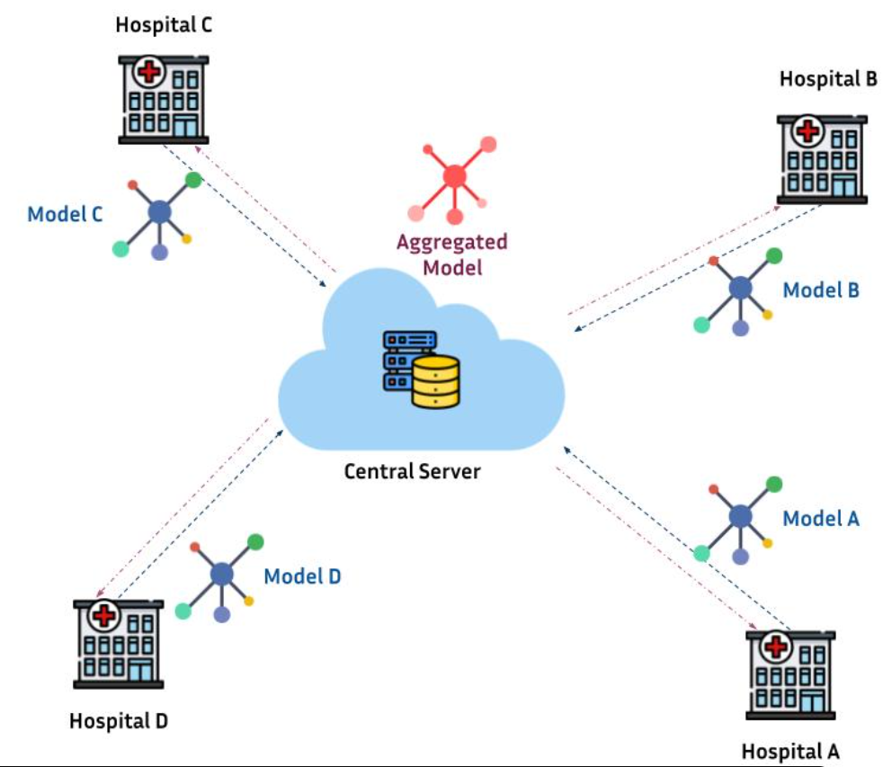
Figure 3.4.Architecture Diagram for Privacy Preserved Medical AI
The system architecture consists of multiple hospitals acting as local nodes where patient data is stored securely. Each hospital trains a local AI model using its own dataset without sharing raw data. A privacy layer ensures encryption and anonymization of model updates before transmission.
These updates are sent to a central aggregation server, where they are combined to form a global model. This global model is then redistributed to all hospitals for improved predictions. This architecture ensures that sensitive medical data never leaves its original location, thereby maintaining privacy.

3.5 System Activity Diagram
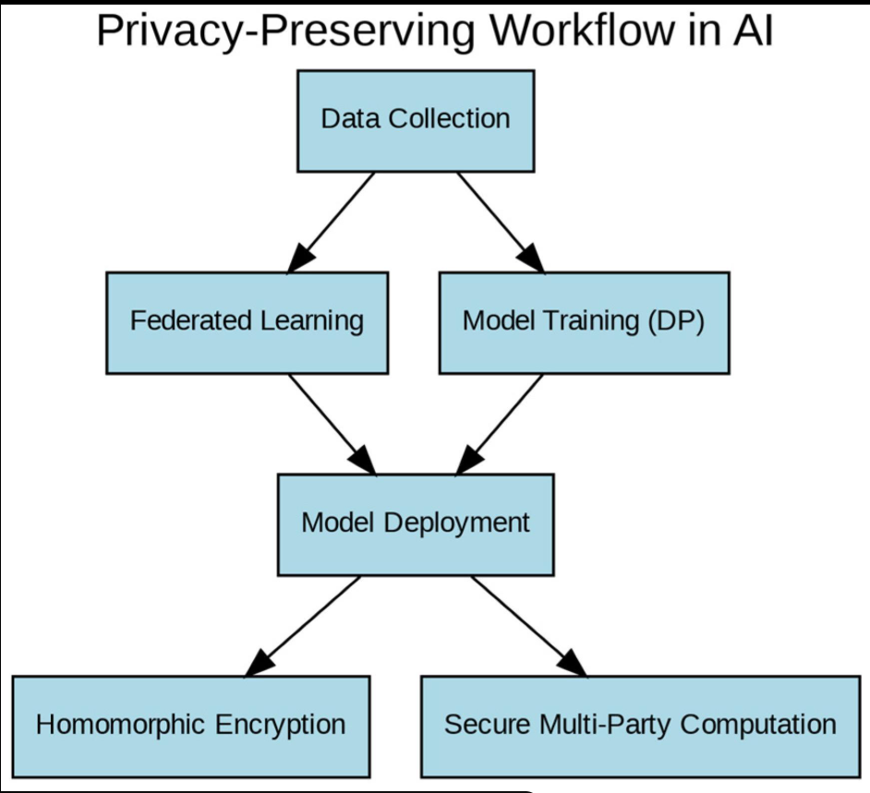 Figure 3.5 Activity Diagram for Privacy Preserved Medical AI
The process begins with collecting medical data from different sources. The data is then preprocessed and anonymized to remove sensitive information. Local models are trained independently at each node.
Next, encrypted model parameters are sent to the central server. The server aggregates these parameters to create a global model. Finally, predictions are generated and shared with users while ensuring data privacy.

CHAPTER 4

REQUIREMENT SPECIFICATION

4.1 Functional Requirements
The system must allow users to input medical data and generate predictions securely. It should support model training, privacy protection, and result visualization. The system should also handle multiple datasets and ensure data consistency.

4.2 Non-Functional Requirements
The system must be secure, reliable, and scalable. It should provide accurate predictions while maintaining high performance. Additionally, it should be easy to use and maintain.

4.3 Hardware Requirements
The system requires a multi-core processor, sufficient RAM, and optional GPU support for faster training. Storage should be adequate to handle medical datasets.

4.4 Software Requirements
The implementation requires programming languages such as Python, libraries like TensorFlow or PyTorch, and frameworks such as Flask for deployment. Database systems like MySQL may be used for data storage.

4.5 Dataset Requirements
The dataset should contain medical records, diagnostic reports, or disease-related data. It should be cleaned and properly formatted before use.

4.7 Constraints
The system is limited by computational resources, availability of datasets, and complexity of privacy techniques. Legal and ethical constraints must also be considered.

CHAPTER 5 METHODOLOGY AND IMPLEMENTATION

5.1 Introduction
This chapter describes the methodology and implementation details of the proposed Privacy Preserved Medical AI system. The system is designed to provide secure and privacy-preserving medical data analysis using Artificial Intelligence techniques. The implementation combines distributed computing, secure data processing, and AI-based prediction methods to ensure that sensitive patient information remains protected during model training and analysis.
The proposed system integrates multiple computational approaches including Serial processing, MPI-based distributed processing, CUDA-based GPU acceleration, and Hybrid MPI+CUDA implementation. These approaches improve computational efficiency while maintaining strong privacy protection mechanisms. Federated learning, encryption, and differential privacy techniques are integrated into the system to prevent unauthorized access to medical records.
The methodology ensures that AI models are trained collaboratively without sharing raw patient data between healthcare institutions. This improves both security and scalability of the healthcare AI system.

5.2 Methodology Framework
The proposed methodology consists of several stages that work together to provide secure medical AI processing. The framework begins with medical data collection from different healthcare institutions. The collected data undergoes preprocessing operations such as cleaning, normalization, and anonymization to remove sensitive personal information.
After preprocessing, privacy-preserving techniques are applied to ensure data confidentiality. Federated learning enables local AI model training within hospitals without transferring patient records to a centralized location. Differential privacy techniques introduce controlled noise into the data or model parameters to prevent data leakage.
The methodology framework includes the following steps:
- Medical Data Collection
- Data Preprocessing and Anonymization
- Privacy Preservation Layer
- Local AI Model Training
- Secure Parameter Sharing
- Global Model Aggregation
- Prediction and Result Generation
The framework ensures secure collaboration between healthcare institutions while maintaining accurate medical predictions.

5.3 Serial Implementation
The Serial implementation acts as the baseline implementation of the Privacy Preserved Medical AI system. In this approach, all computations are executed sequentially on a single CPU without parallel processing. The medical dataset is loaded into memory, preprocessed, and then passed through the AI model for training and prediction.
The serial implementation performs the following operations:
- Reading medical datasets
- Data cleaning and preprocessing
- Applying anonymization techniques
- Training the AI model
- Generating predictions
Although the serial implementation is simple and easy to implement, it suffers from higher execution time when processing large medical datasets. Since all computations are executed one after another, the system becomes slower as dataset size increases.
However, the serial implementation provides a reference model for comparing the performance improvements achieved through MPI and CUDA-based implementations.

5.4 MPI-Based System Implementation
The MPI-based implementation introduces distributed parallel processing into the system using the Message Passing Interface (MPI). In this approach, medical datasets are divided into smaller partitions and distributed across multiple processors or nodes.
Each MPI process performs local computation independently on its assigned dataset partition. After local training is completed, model updates are communicated between processes using MPI communication functions.
The MPI-based implementation includes the following stages:
- Dataset partitioning
- Distributed local model training
- Inter-process communication
- Aggregation of model parameters
MPI improves system scalability and reduces execution time by utilizing multiple CPU cores simultaneously. This implementation is especially useful when handling large-scale healthcare datasets collected from multiple hospitals.
However, communication overhead between MPI processes may slightly reduce performance when the number of nodes increases significantly.

5.5 CUDA-Based System Implementation
The CUDA-based implementation accelerates AI computations using NVIDIA GPUs. CUDA enables thousands of GPU threads to execute parallel operations simultaneously, significantly improving computational speed.
In this implementation, computationally intensive operations such as neural network training and matrix calculations are offloaded to the GPU. CUDA kernels are designed to process large batches of medical data in parallel.
The CUDA-based implementation performs the following operations:
- GPU memory allocation
- Data transfer between CPU and GPU
- Parallel AI model training
- GPU-based prediction generation
CUDA acceleration greatly reduces training time and improves overall system performance. GPU-based processing is highly effective for deep learning models and large medical datasets.
However, CUDA implementation requires NVIDIA GPU hardware and efficient memory management for optimal performance.

5.6 Hybrid MPI+CUDA System Implementation
The Hybrid MPI+CUDA implementation combines distributed MPI processing with GPU acceleration to achieve maximum computational performance. In this approach, MPI distributes the workload across multiple nodes, while CUDA accelerates computations inside each node using GPUs.
The implementation workflow includes:
- Dividing datasets using MPI
- Assigning partitions to different nodes
- Performing GPU-based computations locally
- Aggregating results through MPI communication
The hybrid approach provides two levels of parallelism:
- Inter-node parallelism using MPI
- Intra-node GPU acceleration using CUDA
This implementation achieves the best performance among all approaches because it combines distributed processing and massive GPU parallelism.
The Hybrid MPI+CUDA implementation is highly suitable for large-scale medical AI systems requiring fast and secure computation.

5.7 Memory Management and Optimization
Efficient memory management is essential for improving system performance and reducing computational overhead. The proposed system uses optimized memory allocation techniques for both CPU and GPU computations.
The following optimization techniques are implemented:
- Efficient dataset partitioning
- GPU shared memory utilization
- Reduced communication overhead
- Optimized batch processing
- Parallel memory access
CUDA shared memory is used to reduce global memory access latency during AI computations. MPI communication is optimized to minimize synchronization delays between distributed nodes.
These optimization techniques improve computational efficiency while maintaining stable system performance.

CHAPTER 6 EXPECTED OUTCOME

5.1 Introduction
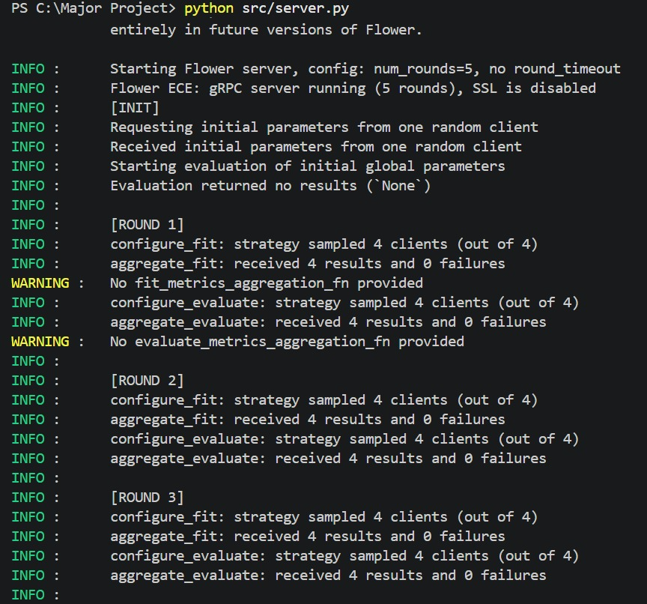
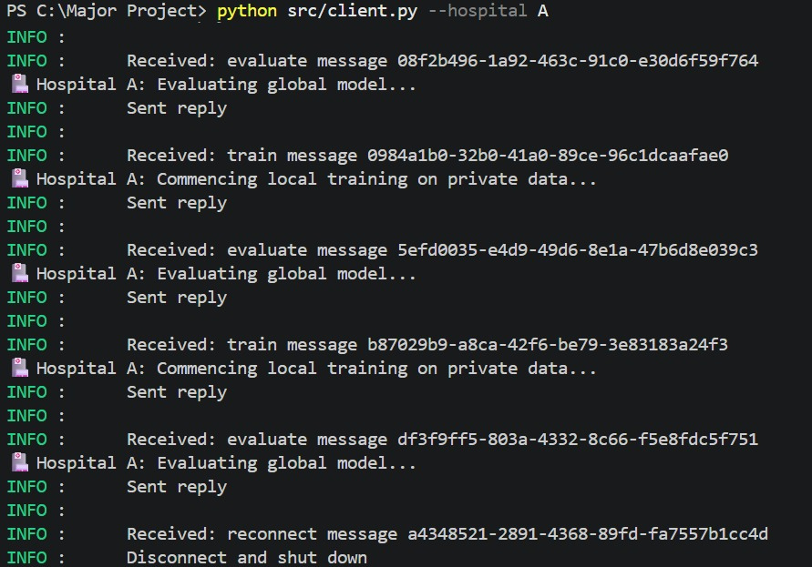
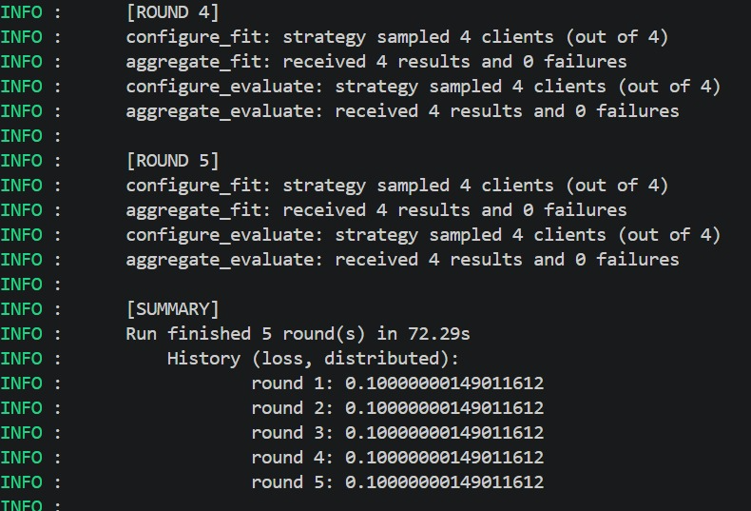
The expected outcome of this project is a secure AI system capable of analyzing medical data without compromising privacy. The system should provide accurate predictions while ensuring that patient information remains protected.
It should demonstrate that privacy-preserving techniques can be effectively integrated into medical AI systems without significant loss in performance.

CHAPTER 7

CONCLUSION AND FUTURE WORK

6.1 Conclusion
This project highlights the importance of privacy in medical AI systems. By integrating advanced techniques such as federated learning and differential privacy, it is possible to develop secure and efficient healthcare solutions. The system ensures that sensitive data is protected while still enabling meaningful analysis.

6.2 Future Work
Future improvements may include integration with real hospital systems, use of blockchain technology for enhanced security, and development of real-time medical monitoring systems. Advanced deep learning models can also be incorporated to improve accuracy.

REFERENCES
[1] McMahan et al. (2017) – "Communication-Efficient Learning of Deep Networks”.

[2] Beutel et al. (2020) – "Flower: A Friendly Federated Learning Framework”.

[3] Krizhevsky et al. (2012) – "ImageNet Classification with Deep CNNs"

[4] Li et al. (2023) – "Federated Learning: Challenges, Methods, and Future Directions"
[5] Rajpurkar et al. (2021) – "CheXNet: Radiologist-Level Pneumonia Detection"
[6] Dayan et al. (2021) – "Federated Learning for Predicting Outcomes in COVID-19"
[7] Mabrouk et al. (2025) – "Federated Learning for Pediatric Pneumonia Detection"

[8] Sheller et al. (2020) – "Federated Learning in Medicine"

[9] Kovačević et al. (2025) – "HIPAA Compliance in Decentralized Medical AI".

[10] Kaissis et al. (2025) – "Secure Multi-party Computation for FL"

